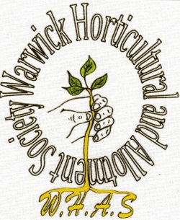
WARWICK HORTICULTURAL
and ALLOTMENT SOCIETY

TRADING HUT OPEN SUNDAYS
10-12
MEMBERS’ PRICE LIST – APRIL 2019

HUMAX COMPOST 60L £4.90
HUMAX GROWBAGS £2.60
GROW ORGANIC FERTILISER £7.20
JOHN INNES SEED AND 1,2,3 £3.50
BONEMEAL 2Kg £1.60
FISH BLOOD AND BONE 2Kg £1.40
GROWMORE 2Kg £1.95
CHICKEN MANURE 15kg £6.10
VERMICULITE 2L 50p
PERLITE 2L 40p
ENVIROMESH NETTING /M £2.00
HORTICULTURAL GRIT £3.70

ALSO CANES, FLEECE, BIRD NETTING, PLANT FOOD, SAND, SLUG KILLER etc
ALL AT VERY REASONABLE PRICES!

