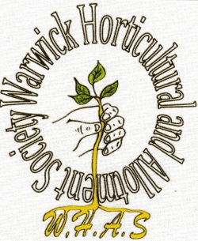
WARWICK HORTICULTURAL
and ALLOTMENT SOCIETY

Calendar of events 2019

19th March WHAS AGM
16th April Priory Park – Working to ensure its future
14th May Hanging basket demonstration
19th June (3p.m.) Lord Leycester Hospital – Master’s Garden: Walk, talk and tea
30th June Trip to Usk Open Gardens
16th July Summer quiz
24th August WHAS Annual show: Exhibiting and Judging
25th/26th August WHAS Annual Show in the Pageant Garden and Court House
17th September Harvest event and produce sale
15th October Garden history in Warwickshire
19th November Seasonal demonstration

